Iñigo Gonzalez Portela
ingonzal@student.42urduliz.com

Caso Practico 1: Infraestructura Global y Seguridad en AWS
Tarea 1:
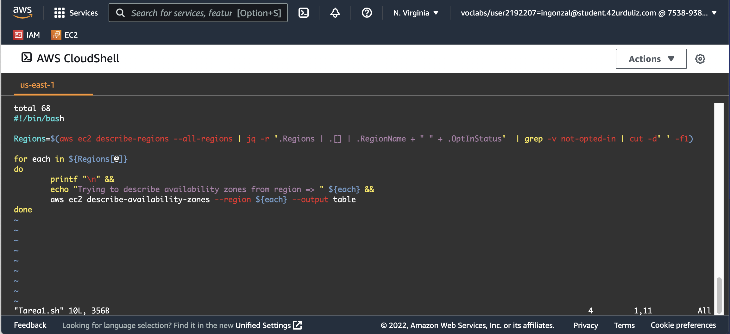
Transcript 1:
#!/bin/bash
Regions=$(aws ec2 describe-regions --all-regions | jq -r '.Regions | .[] | .RegionName + " " + .OptInStatus' | grep -v not-opted-in | cut -d' ' -f1)

for each in ${Regions[@]}
do
printf "\n" &&
echo "Trying to describe availability zones from region => " ${each} &&
aws ec2 describe-availability-zones --region ${each} --output table
done

Tarea 2:
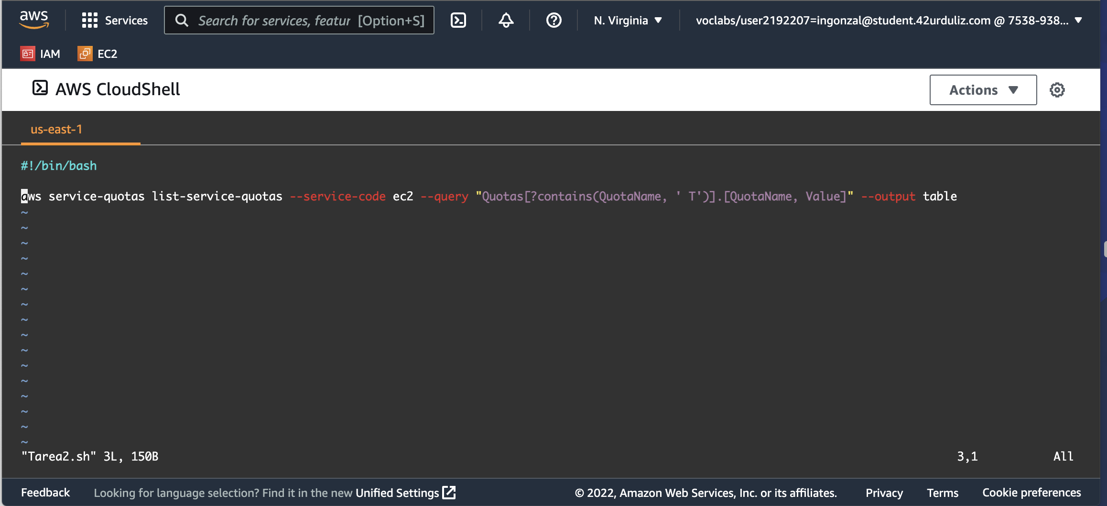
Transcript 2:
#!/bin/bash
aws service-quotas list-service-quotas --service-code ec2 --query "Quotas[?contains(QuotaName, ' T')].[QuotaName, Value]" --output table

